https://www.regulations.gov/comment/IRS-2022-0022-0163
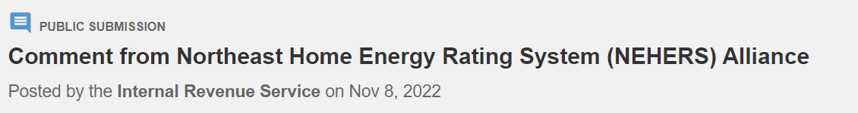
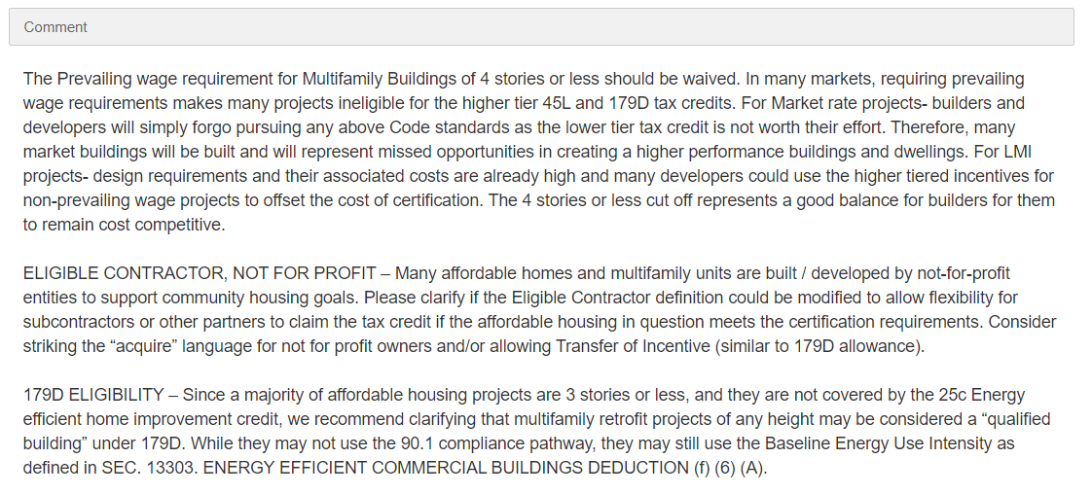
https://www.regulations.gov/comment/IRS-2022-0022-0164
